**Problem set -3**

**Length of stay tab**

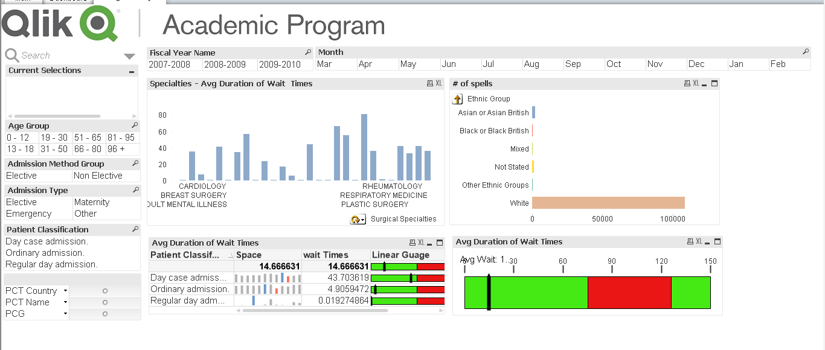

**Wait time tab**

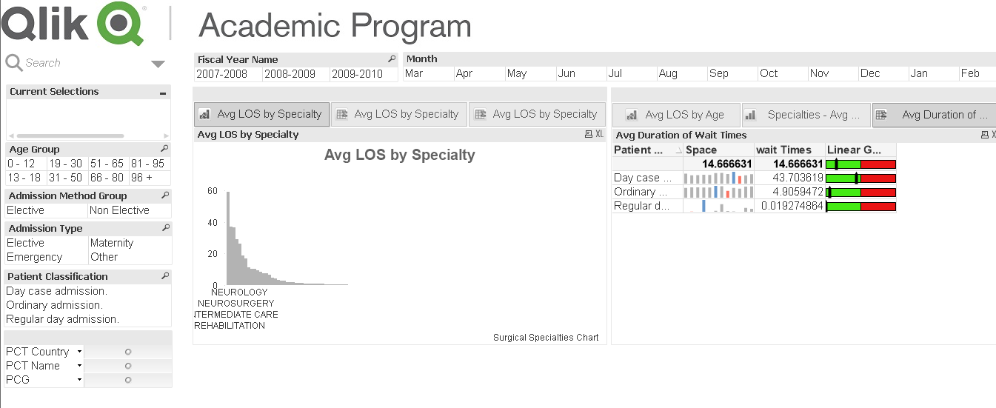

1. What specialty had the least duration of wait times?

**Ans:**

For Clinical Hematology has least wait time of 0.0078

1. What was the average wait time for Pain Management patients in December of 2008- 2009?

Ans: Day case admissions – 90.34375.

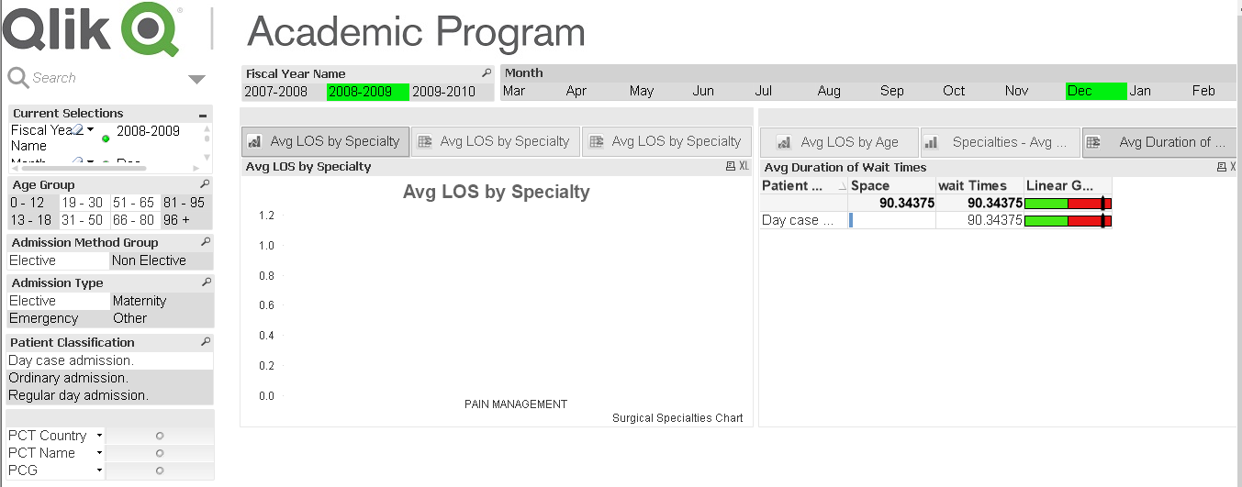

1. What is the average wait time for plastic surgery patient’s ages 19 -30?

Ans: Average wait time for plastic surgery patients is 40.614

For day case admission – 57.53

Ordinary admission – 31.91

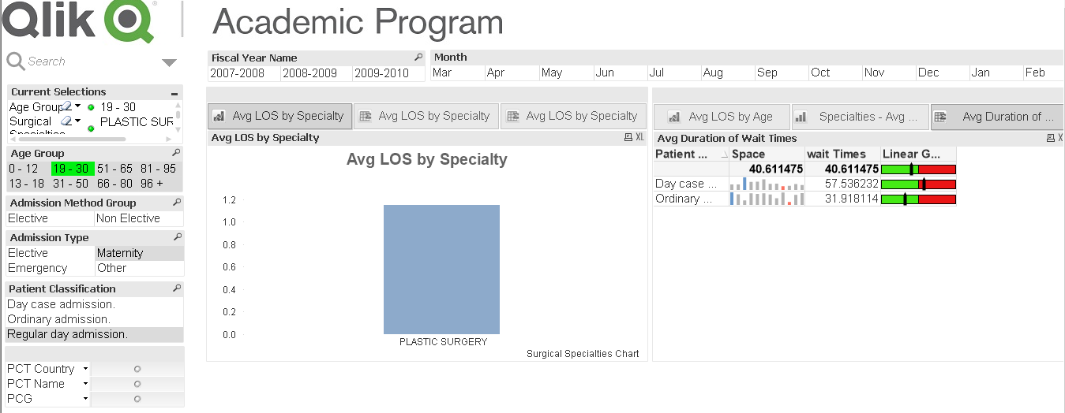

4) What was the average wait time for day case admission in October of 2009 – 2010

Ans: Wait time is 38.50

5) How many oral surgery patients were white during September 2009- 2010?

Ans: 157

6) What was the average length of stay for a patient in neurology, both elective and nonelective in August 2009 – 2010?

Ans: It is 24

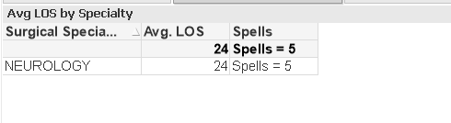

7) What was the average length of stay for patients in the 81 to 95 age group in August 2008 – 2009?

Ans: It is 7.39377

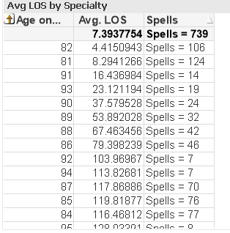

8) What specialty has an average length of stay of 10.22 days?

Ans: It’s neonatology

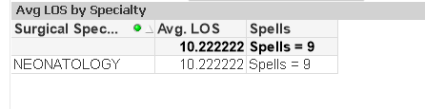

9) For age group 0 – 12, what is the average length of stay?

Ans: It is 1.517

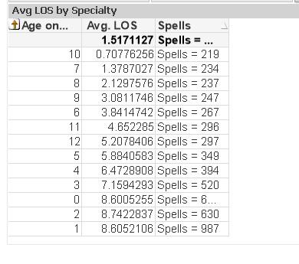

10) How many spells did emergency pediatrics have from 2007 – 2010?

Ans: It is 4907

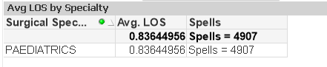

1. Submit a 2–3-paragraph written comparison of QlikView and Google Public Data, which you met earlier, in terms of ease of use, flexibility, and the strengths and weaknesses of each visualization tool

Ans:

**QlikView** has different types of objects and we can use those objects in different containers. Qlik view is a solution that focus on the user as the receiver of data. It allows user to explore and discover your data in a workflow similar to the way developers work when processing data. Qlik view is incredibly flexible. It allows to set and tweak every little aspect of each object and customize the look and feel of any visualization and dashboards.

**Usability**

QlikView’s dashboards and reports are easy to navigate even for ordinary users. However, it can be quite challenging to build the reports, as it requires a high level of developer skills

**Goggle public data** is new to the market. It is simple with beautiful design, innovative problem-solving and straight forward, habitual ways to share dashboards. While still being in Beta, Google data studio gives an interesting insight into how it can process the data.

Google aspires to hit the right spot on the market with not just going for a single BI tool, but also promoting all their other tools for working with data by conveniently combining them into the Google Analytics Solutions data toolkit, a software suite for analyzing data and facilitating data-driven solutions.